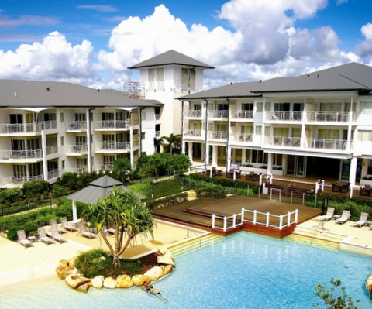

Biometrics by the Border

Kingscliff, NSW

26-30 November 2017